In the last video you explored how audio is preprocessed for Keyword Spotting.

You saw that the raw **analog** audio signal is first transformed into a **digital** signal.

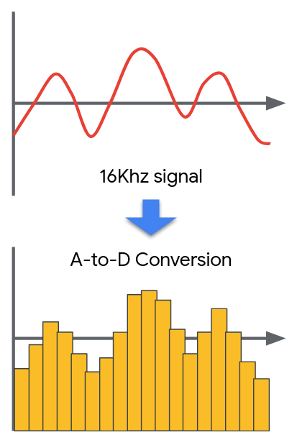

<Alt text: Raw smooth analog signal converted to a chunked up digital figure.>

You then saw how the digital signal in the **time domain** (time on the x-axis and amplitude on the y-axis) is transformed into the **frequency domain** (frequency on the x-axis and amplitude on the y-axis) through the use of a **fourier transform**. If you’d like to dive deeper into understanding how the fourier transform works we suggest you watch [this fantastic video on the 3Brown1Blue youtube channel](https://www.youtube.com/watch?v=spUNpyF58BY).

Of course for the purposes of TinyML we need to worry about how we can compute this transformation efficiently -- both in the memory needed to store the program, and in the memory and latency needed for the computation. The solution is the use of an approximate **fast fourier transform (FFT)** of which there are multiple possible implementations**.** TensorflowLite Micro uses [the KISS_FFT library](https://github.com/mborgerding/kissfft), which includes more documentation about the design choices made by the library to be compact in memory on their GitHub page.

By applying the FFT through a sliding window procedure we can analyze the intensity (in color) of each of frequencies over time. This is a **spectrogram**.

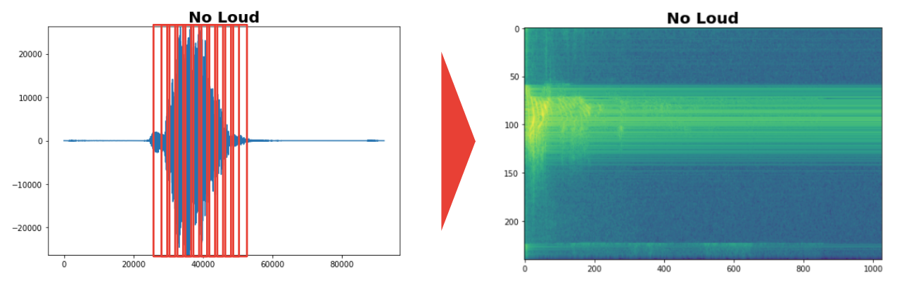

<Alt text: Sliding window of FFT is used to render spectrogram of frequency intensity.>

A spectrogram is a better input for a deep learning system than the standard input audio signal as we have already extracted the frequencies for the neural network and so it doesn’t need to learn how to do that on its own. Even visually, it is easier to see the difference between the “yes” and “no” spectrograms.

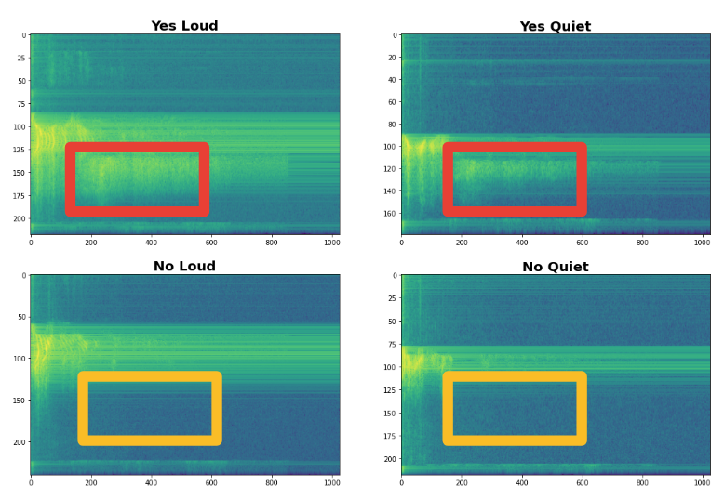

<Alt text: Spectrograms with yes and no loud instances, and yes and no quiet instances.>

We then discussed how the human ear can tell low frequency signals apart easier than high frequency signals according to the Mel Scale. We can therefore create a **Mel Filter Bank** to take advantage of this phenomenon and group together larger clusters of higher frequency signals to provide more useful data to our machine learning algorithm. The output of this process is a **Mel Frequency Cepstral Coefficient (MFCC).** For more information on how this works [check out this post](http://practicalcryptography.com/miscellaneous/machine-learning/guide-mel-frequency-cepstral-coefficients-mfccs/).

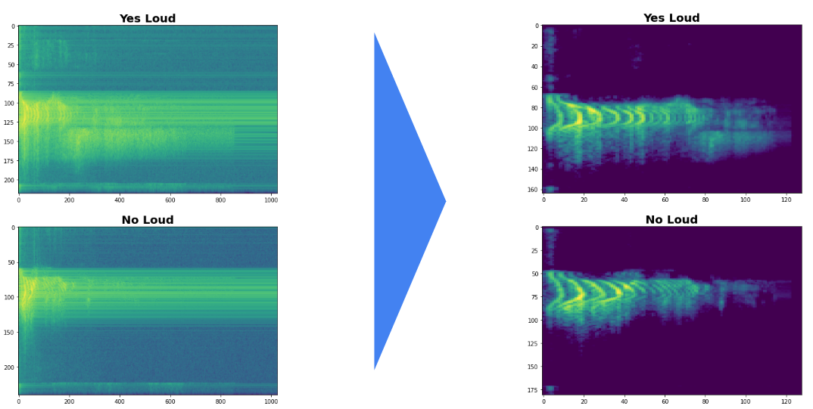

<Alt text: Spectrograms and their corresponding MFCCs>

Of course there are many different ways you could solve this learning problem and it is likely that very large neural networks would perform quite well on this task without this preprocessing. However, for the case of TinyML this preprocessing is vital and drastically improves the final model performance without taking up a lot of memory or latency!

In Course 2, we will use these methods via Google Colab but in Course 3 you will learn how to deploy these pre-processing methods directly onto the embedded hardware platform.